**Notițe CSS**

(W3Schools Source)

* CSS Selectors

To select an element with a specific id, write a hash (#) character, followed by the id of the element:

#para1 {

text-align: center;

color: red;

}

To select elements with a specific class, write a period (.) character, followed by the class name:

.center {

text-align: center;

color: red;

}

You can also specify that only specific HTML elements should be affected by a class:

p.center {

text-align: center;

color: red;

}

The universal selector (*) selects all HTML elements on the page.

To group selectors, separate each selector with a comma:

h1, h2, p {

text-align: center;

color: red;

}

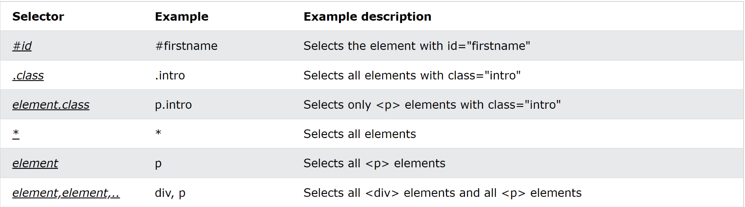

External style: another file .css

Internal style: using <style></style> tag

Inline style: write style as attribute:

<h1 style="color:blue;text-align:center;">Sall</h1>

* CSS Colors

Ways to set background colors (Tomato color):

<h1 style="background-color:rgb(255, 99, 71);">...</h1>

<h1 style="background-color:#ff6347;">...</h1>

<h1 style="background-color:hsl(9, 100%, 64%);">...</h1>

<h1 style="background-color:rgba(255, 99, 71, 0.5);">...</h1>

<h1 style="background-color:hsla(9, 100%, 64%, 0.5);">...</h1>

hsl(hue, saturation, lightness): hue - a degree from 0 to 360

saturation - a percentage value: 0% - gray

100% - full color

lightness - 0% - black, 100% - white

alpha (for hsla) - from 0.0 to 1.0: 0.0 - transparent

* CSS Backgrounds

To set the background image repeat only horizontally:

background-image: url("gradient_bg.png");

background-repeat: repeat-x; // or repeat-y; no repeat;

background-position: right top;

background-attachment: fixed; //or scroll;

repeat - there also exist repeat-y and no-repeat

position - also we can set the position where the image will be displayed

attachment - the image remains fixed in the window even if we scroll

If we want to shorten the code, the following line is equivalent to the 4 lines from above:

background: url("gradient_bg.png") repeat-x right top fixed;

background-clip and background-origin have border-box, padding-box, content-box attributes.

// these are used to position the image somewhere in the window.

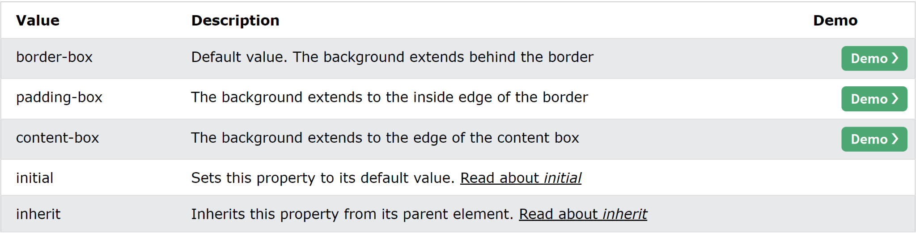

* CSS Borders

p.dotted {border-style: dotted;}

p.dashed {border-style: dashed;}

p.solid {border-style: solid;}

p.double {border-style: double;}

p.groove {border-style: groove;}

p.ridge {border-style: ridge;}

p.inset {border-style: inset;}

p.outset {border-style: outset;}

p.none {border-style: none;}

p.hidden {border-style: hidden;}

p.mix {border-style: dotted dashed solid double;}

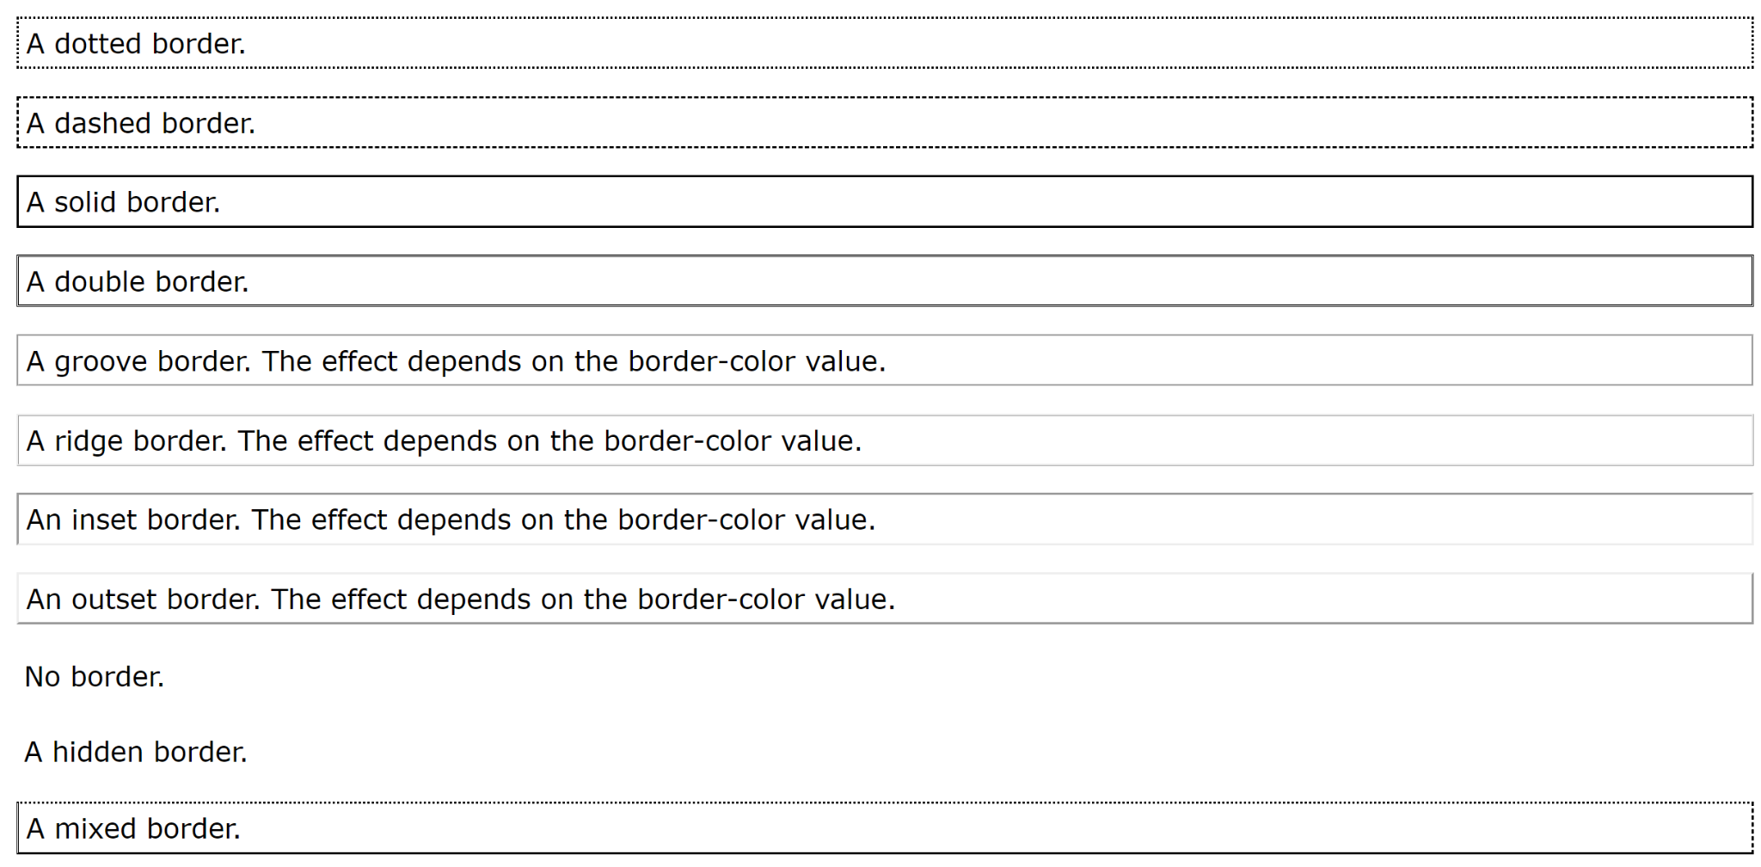

There exist also border-left-style, border-top-style….

border-width: 25px 10px 4px 35px; /* 25px top, 10px right, 4px bottom and 35px left */

border-width: 20px 5px; /* 20px top and bottom, 5px on the sides */

border-color: red green blue yellow; /* red top, green right, blue bottom and yellow left */

border-radius: 5px; //to add rounded borders

* CSS Margins

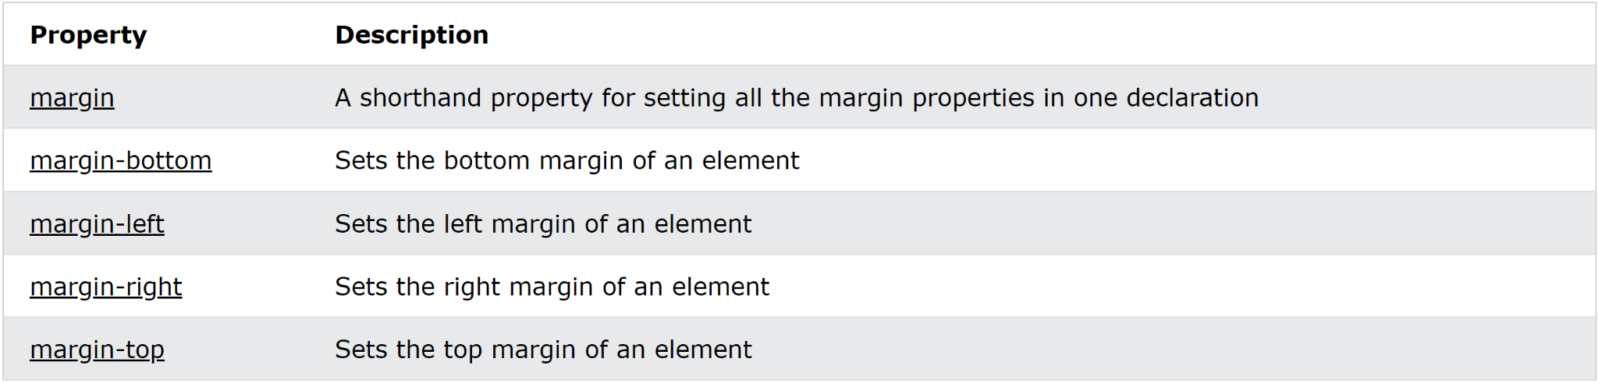

The margin-bottom and margin-top collapse, meaning if margin-bottom for the first element is 50px and margin-top for the second element is 20px, the margin will be 50px, not 70px (Works just for bottom and top).

margin:... values:

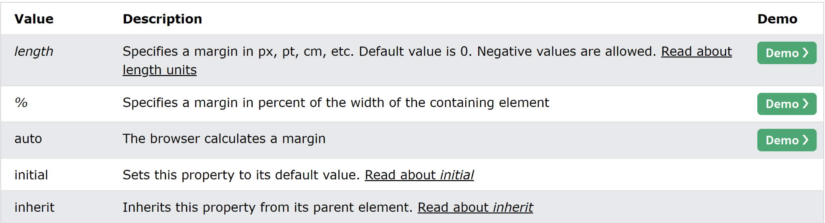

* CSS Padding

When we use width and padding at the same time, the px values add up, which is often undesirable. To avoid this, you can use box-sizing property:

div {

width: 300px;

padding: 25px;

box-sizing: border-box;

}

undesirable result: desirable result: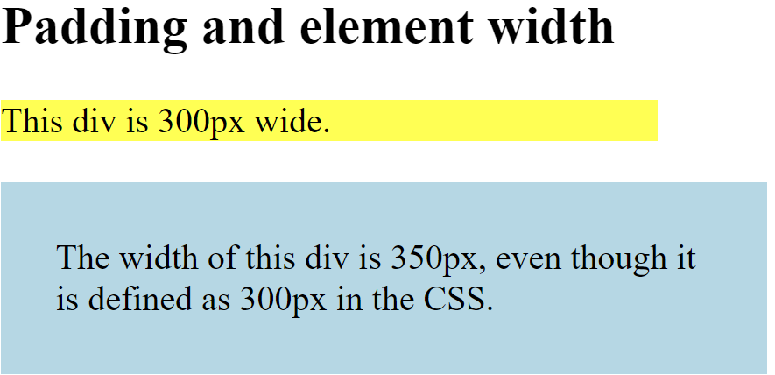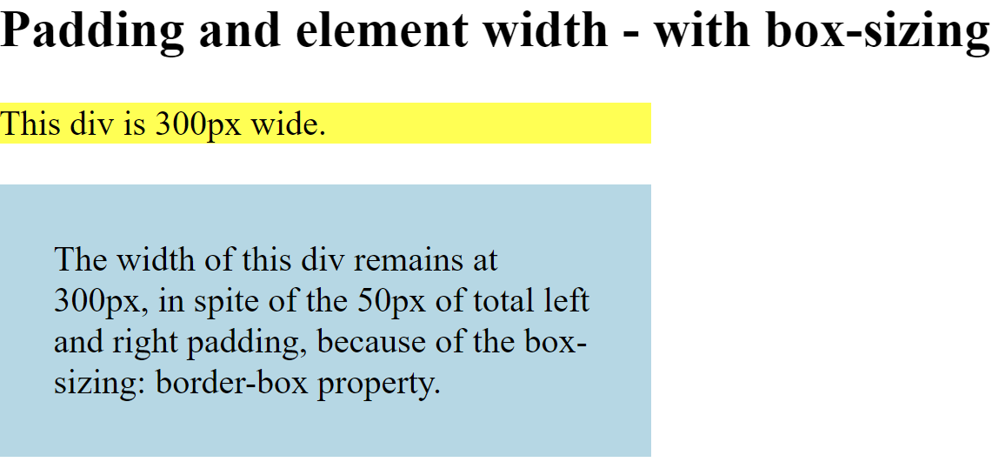

* CSS Height/Width

The CSS height and width properties are used to set the height and width of an element.

The CSS max-width property is used to set the maximum width of an element.

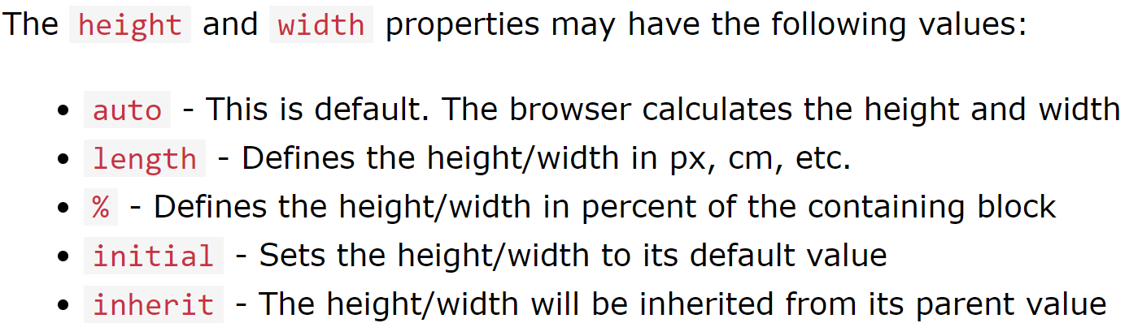

* CSS Box Model

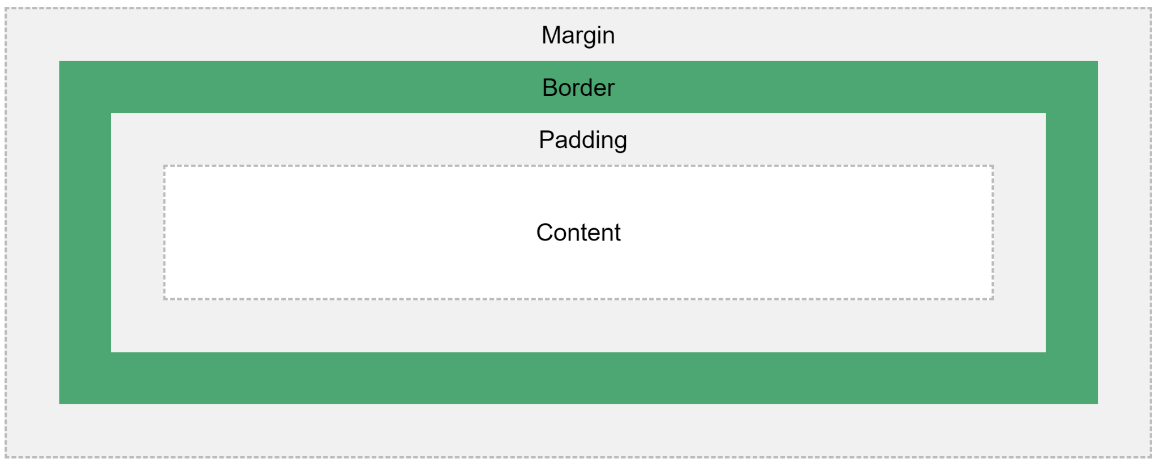

* CSS Outline

An outline is a line drawn outside the element’s border.

It may overlap other content, because it is not part of the element’s dimensions.

The outline-style property can have all the values from “CSS Borders” section. Also, it has all the other properties that borders have (and their values). Only outline-offset is new!

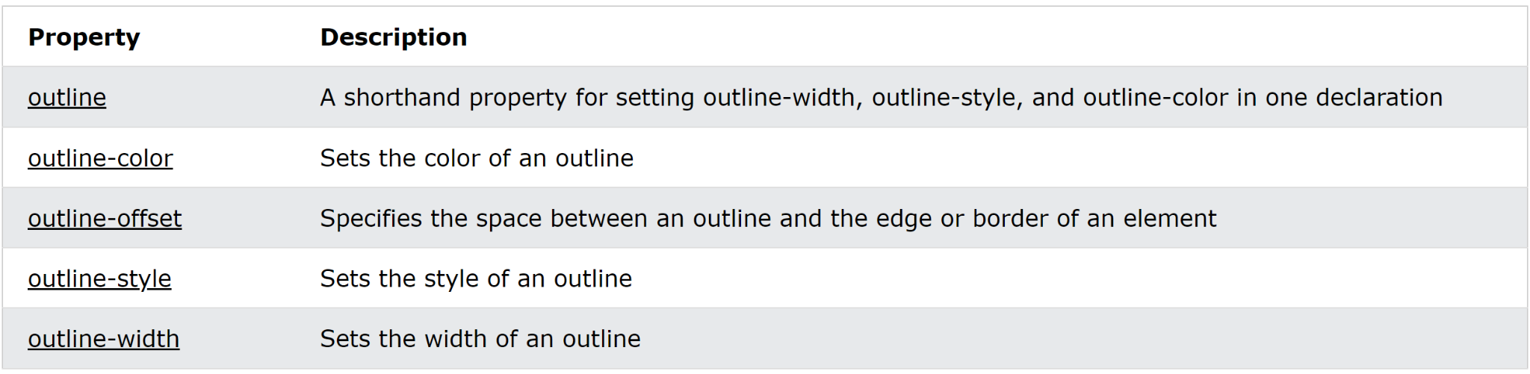

* CSS Text

direction property - sets the text direction (values are: rtl, ltr)

unicode-bidi property - sets the text direction (values are: bidi-override)

For some reason, they must be used together in order to work.

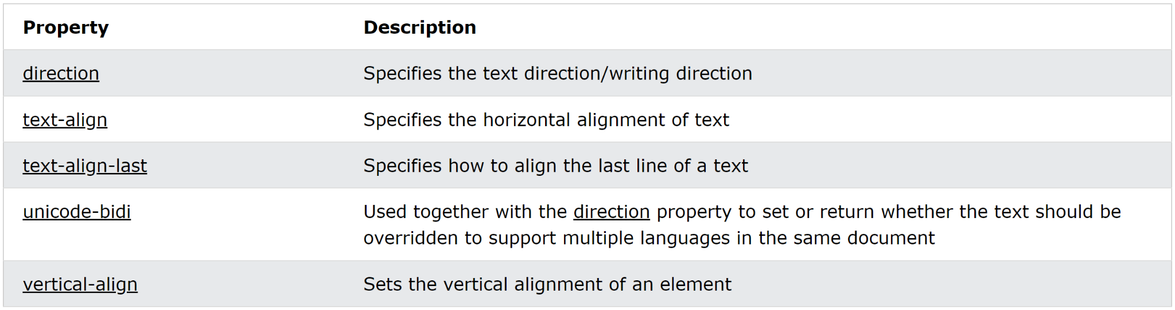

vertical-align values are: baseline, text-top, text-bottom, sub, super.

text-decoration-line values are: overline, line-through, underline: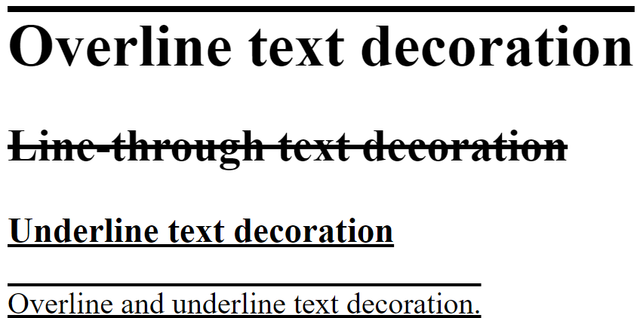

Also you can specify a color to the decoration line using text-decoration-color property and specify a style for it using text-decoration-style property and set the thickness using text-decoration-thickness property (values in px).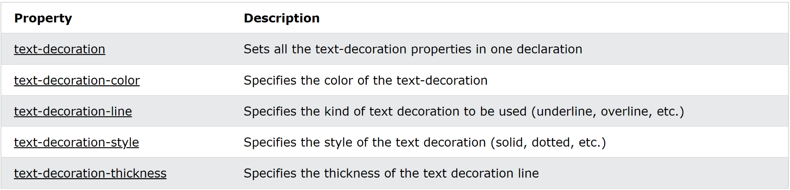

text-decoration-color - specify a color to the decoration line

text-decoration-style - specify a style for the decoration line

text-decoration-thickness - set the thickness (its values are in px)

text-transform - transform the text into “uppercase”, “lowercase”, “capitalize” (these are the values ^_^)

text-indent - specify the indentation of the first line of a text (in px)

letter-spacing - specify the space between the characters in a text (in px; works with negative numbers!)

line-height - specify the space between lines (ex. values: 0.8, 1.8, etc.)

word-spacing - specify the space between the words in a text (in px; works with negative numbers!)

white-space - specify how the white-space inside an element is handled. The values are:

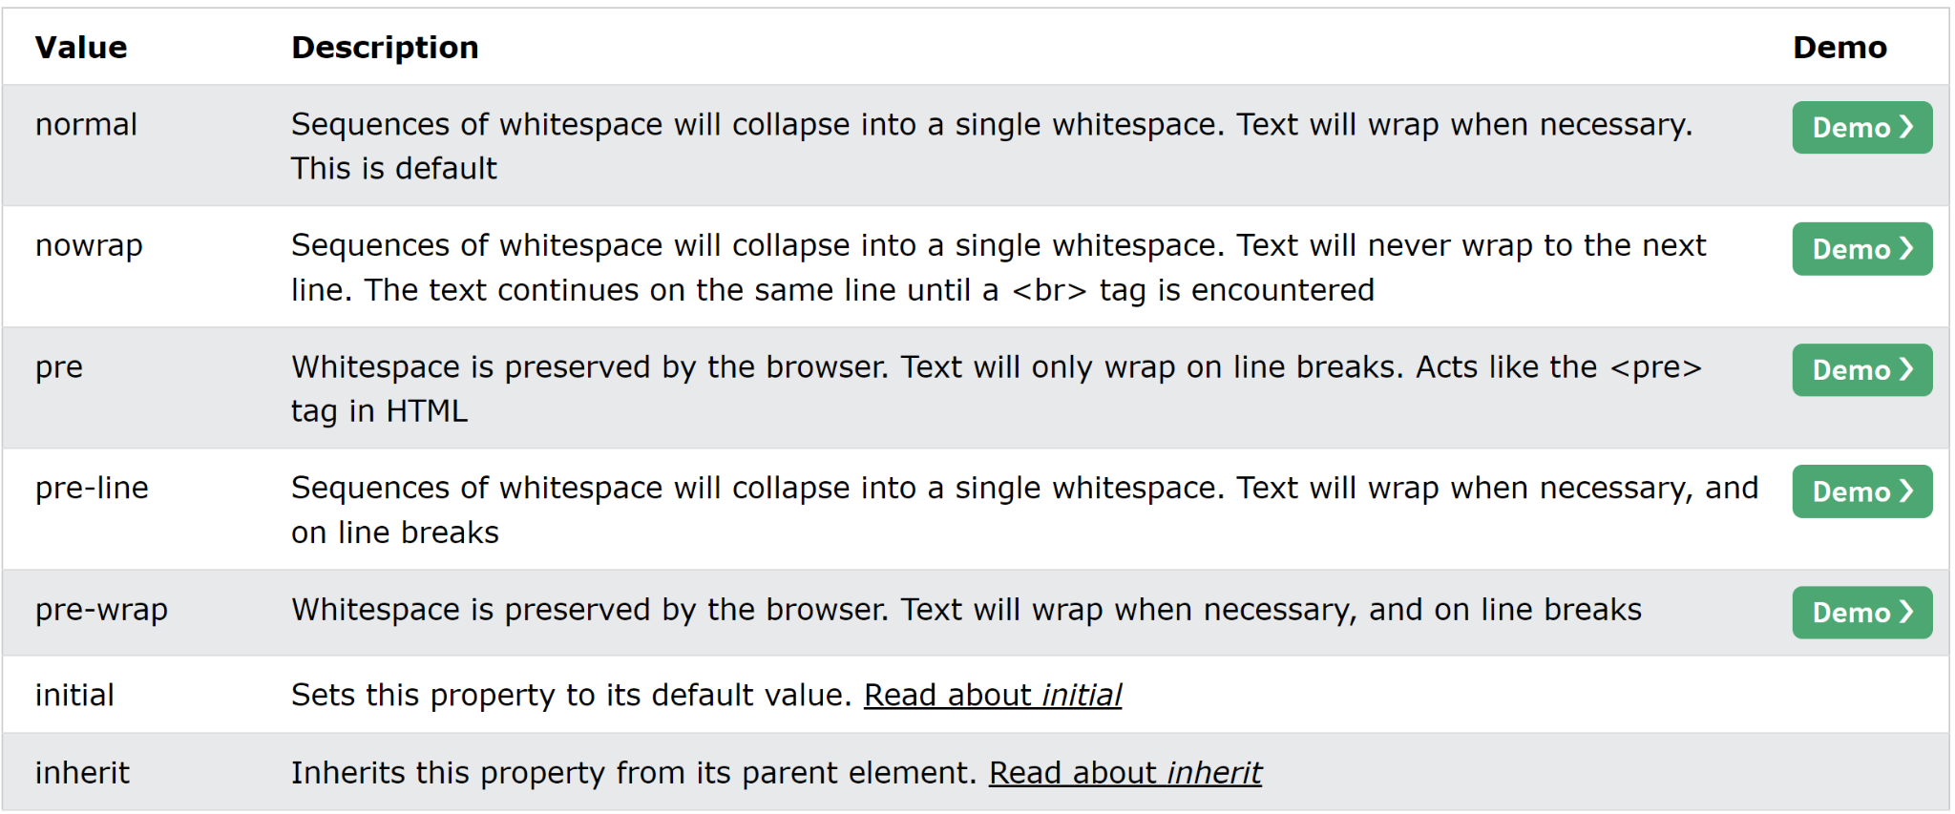

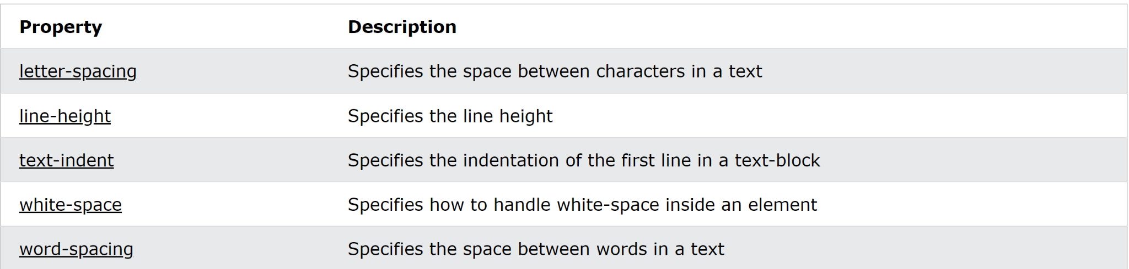

text-shadow - adds shadows to text (values in px, you specify the horizontal shadow and the vertical shadow): text-shadow: 2px 2px 5px red;

The third value is the blur.

* CSS Fonts

font-family - specify the font of a text

It is a good practice to write more fonts in case the first fonts are not available: font-family: Tahoma, Verdana, sans-serif;

font-style - used to specify italic text (values are: normal, italic, oblique (less supported))

font-weight - used to apply bold to a text (values are: normal, bold)

font-variant - used to apply small-caps or not (values are: normal, small-caps)

font-size - apply size to text (values are: px, %, em - for allowing users to resize the text (1 em = 16px), vw - for resizing the text according to the size of the window)

Good To Know:

Georgia font - good for headings

Verdana font - good for paragraphs

You can use all the properties in one like this:

font: italic small-caps bold 12px/30px Georgia, serif;

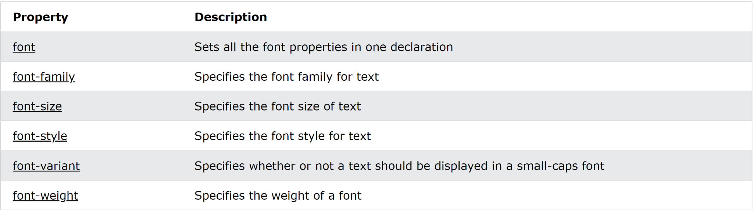

* CSS Links

/* unvisited link */

a:link {

color: red;

}

/* visited link */

a:visited {

color: green;

}

/* mouse over link */

a:hover {

color: hotpink;

}

/* selected link */

a:active {

color: blue;

}

a:hover MUST come after a:link and a:visited

a:active MUST come after a:hover

Funny Feature:

This example demonstrates different types of cursors:

<span style="cursor: auto">auto</span><br>

<span style="cursor: crosshair">crosshair</span><br>

<span style="cursor: default">default</span><br>

<span style="cursor: e-resize">e-resize</span><br>

<span style="cursor: help">help</span><br>

<span style="cursor: move">move</span><br>

<span style="cursor: n-resize">n-resize</span><br>

<span style="cursor: ne-resize">ne-resize</span><br>

<span style="cursor: nw-resize">nw-resize</span><br>

<span style="cursor: pointer">pointer</span><br>

<span style="cursor: progress">progress</span><br>

<span style="cursor: s-resize">s-resize</span><br>

<span style="cursor: se-resize">se-resize</span><br>

<span style="cursor: sw-resize">sw-resize</span><br>

<span style="cursor: text">text</span><br>

<span style="cursor: w-resize">w-resize</span><br>

<span style="cursor: wait">wait</span>